A
PBL Project Report Entitled On
AI Assistant for Academic Syllabus in LMS

In partial fulfilment of the requirements for the award of

BACHELORS OF TECHNOLOGY
In
Computer Science Engineering(Data Science)
Submitted by
Sai Vikas | 24E51A6739
Madhan | 24E51A6702
Nuthan | 24E51A6707
Karthik | 24E51A6762

Under the Esteemed guidance Of
Ms. Richa Tiwari
(Assistant Professor)


DEPARTMENT OF COMPUTER SCIENCE AND ENGINEERING(AI & ML)
HYDERABAD INSTITUTE OF TECHNOLOGY AND MANAGEMENT
Gowdavelly (Village), Medchal, Hyderabad, Telangana, 501401
(UGC Autonomous, Hyderabad, Accredited by NAAC(A+), NBA)

2025-26
HYDERABAD INSTITUTE OF TECHNOLOGY AND MANAGEMENT
(UGC Autonomous, Hyderabad, Accredited by NAAC(A+), NBA)
DEPARTMENT OF COMPUTER SCIENCE AND ENGINEERING(Data Science)



CERTIFICATE
This is to certify that the PBL Project work entitled “AI Assistant for Academic syllabus in LMS” is a bonafide work carried out by Sai Vikas bearing 24E51A6739, Madhan bearing 24E51A6702, Nuthan bearing 24E51A6707, Karthik bearing 24E51A6762 in partial fulfilment of the of the requirements for the degree BACHELOR OF TECHNOLOGY in COMPUTER SCIENCE AND ENGINEERING (Data Science) by the Jawaharlal Nehru Technological University, Hyderabad, during the academic year 2025-2026. The matter contained in this document has not been submitted to any other University or institute for the award of any degree or diploma

Internal Supervisor |  | Head of the Department
Ms.Richa Tiwari |  | Dr.K.David Raju
Asst Professor |  | Professor & HOD

External Examiner

HYDERABAD INSTITUTE OF TECHNOLOGY AND MANAGEMENT
Gowdevelly(Village), Medchal, Hyderabad, Telangana, 501401 Department of Computer Science and Engineering(Data Science)

DECLARATION

We, Vikas (24E51A6739), Madhan (24E51A6702), Nuthan (24E51A6707), Karthik (24E51A6762), students of Bachelor of Technology in CSD, session 2025–2026, Hyderabad Institute of Technology and Management, Gowdavelly, Hyderabad, Telangana State, hereby declare that the work presented in this project entitled “AI Assistant for academic syllabus in LMS” is the outcome of our own bona fide effort and is correct to the best of our knowledge. This work has been carried out adhering to engineering ethics. It contains no material previously published or written by any other person, nor material accepted for the award of any other degree or diploma of the university or any other institute of higher learning, except where due acknowledgement has been made in the text.

Sai Vikas | 24E51A6739
Madhan | 24E51A6702
Nuthan | 24E51A6707
Karthik | 24E51A6762

ACKNOWLEDGMENT

An endeavour of a long period can only be successful with the guidance and encouragement of many well-wishers.
We express our deep sense of gratitude to our Chairman, Sri Arutla Prashanth, for providing us with all the facilities required to carry out our project work successfully.
We extend our sincere thanks to our Honourable Principal, Dr. Arvind, whose inspiring words and encouragement have greatly motivated us and for providing us with this opportunity to undertake our PBL project.
We are highly grateful to our Head of the Department Dr. K.David Raju , our Program Head Mr.Bhaskar Das and B.Tech PBL Coordinator, Ms.Richa Tiwari, for their constant support and valuable guidance throughout the course of this work.
We would like to make a special mention of our Guide, Ms.Richa Tiwari, for his invaluable technical guidance, continuous encouragement, and immense support, which helped us in the successful completion of our project.
We also extend our heartfelt thanks to all the Departmental Committee (D.C.) and PBL Review Committee (P.R.C.) members, as well as the non-teaching staff, for their cooperation and assistance in the successful completion of this project.
Last but not least, we express our sincere gratitude to our family members and friends for their continuous encouragement, moral support, and care, which have been our strength throughout this journey.

Sai Vikas | 24E51A6739
Madhan | 24E51A6702
Nuthan | 24E51A6707
Karthik | 24E51A6762

TABLE OF CONTENTS

S. No | Contents | Page No
 | ABSTRACT | 1
1. | INTRODUCTION | 2
 | 1.1 Background & Context of the Project | 2
 | 1.2 Justification for Project Selection | 2
 | 1.3 Problem Statement | 2
 | 1.4 Project Objectives | 2
2. | LITERATURE REVIEW / RELATED WORK | 4
3. | METHODOLOGY | 6
 | 3.1 Data & Collection | 6
 | 3.2 Data Cleaning & Steps | 6
 | 3.3 Tools and Technologies Used | 6
 | 3.4 Rationale | 6
 | 3.5 Final Data State and Analysis Readiness | 7
4. | RESULTS & INTERPRETATION | 8
 | 4.1 Key Findings | 8
 | 4.2 Results | 8
5. | DISCUSSION | 11
 | 5.1 Challenges & Limitations | 11
 | 5.2 Lessons Learned | 11
 | CONCLUSION | 12
 | FUTURE SCOPE | 13
 | REFERENCES | 14

LIST OF FIGURES

FIGURE NO. | NAME OF THE FIGURE | PAGE NO.
Figure 4.2.1 | Main Dashboard Interface | 9
Figure 4.2.2 | AI Assistant Bottom Sheet Interface | 9
Figure 4.2.3 | Full-screen AI Chat Interface | 10
Figure 4.2.4 | AI Chat Demonstration | 10

ABSTRACT

The AI Assistant for Academic Syllabus in LMS is an intelligent academic support system designed to enhance the learning experience of students through personalized and context-aware assistance. The platform integrates an AI-powered assistant within the Learning Management System (LMS) to help students navigate academic resources, understand course materials, manage assignments, and resolve common platform-related issues efficiently.

By utilizing contextual screen data and user interactions, the AI provides more relevant and accurate responses in real time, improving accessibility and reducing dependency on manual support. The system includes features such as smart resource discovery, syllabus guidance, assignment assistance, and academic query handling to support students throughout their learning journey.

A user-friendly bottom-sheet interface enables seamless AI interaction without interrupting the workflow of the LMS environment. The platform is designed with scalability and usability in mind, ensuring smooth integration with modern educational systems. The proposed solution aims to improve student engagement, learning efficiency, and overall digital academic support within educational institutions.

1. INTRODUCTION
1.1 Background & Context of the Project
Learning Management Systems (LMS) have become an integral part of modern higher education institutions. These platforms serve as central hubs for course materials, assignments, announcements, and academic interactions between students and faculty. With the growing complexity of digital academic environments, students increasingly depend on LMS platforms to manage their academic workload and access learning resources effectively.

However, despite the widespread adoption of LMS platforms across colleges and universities, these systems remain largely static in their support capabilities. Students often struggle to find specific resources, understand module structures, navigate the syllabus effectively, or resolve common platform-related issues without direct faculty or administrative intervention.

1.2 Justification for Project Selection
The motivation for this project arose directly from the day-to-day academic challenges faced by students at our institution. Through observations of peers and classmates, the team identified a clear and recurring need for intelligent, real-time academic assistance within the LMS environment. Existing platforms such as Moodle, Google Classroom, and Canvas offer robust content management features but lack contextual intelligence and conversational AI capabilities that can proactively support students.

The integration of AI into an LMS presented an opportunity to bridge this gap and deliver a system that not only manages content but actively assists students in their academic journey through smart, context-aware interactions.

1.3 Problem Statement
Current LMS platforms provide limited intelligent support. Students face difficulties in locating relevant study materials, understanding course structures, and getting timely responses to academic queries. The absence of a context-aware AI assistant within the LMS forces students to rely on manual support channels, leading to delays in resolution, increased academic confusion, and reduced engagement with the platform.

1.4 Project Objectives
The primary objectives of this project are:
- To develop an AI-powered assistant integrated directly within the LMS platform.
- To provide smart, context-aware academic support based on real-time screen understanding.
- To improve LMS usability and help students access resources quickly and efficiently.
- To reduce student dependency on manual support through automated intelligent query handling.
- To implement a seamless and non-intrusive bottom-sheet UI for AI interaction within the LMS.
- To ensure scalability and compatibility with modern educational technology infrastructure.

2. LITERATURE REVIEW / RELATED WORK
A comprehensive review of existing research and platforms was conducted to understand the current state of AI integration in educational technology and Learning Management Systems.

AI in Education:
Research in the domain of AI in education has consistently demonstrated the positive impact of intelligent systems on student learning outcomes. Studies have shown that AI-driven tools improve student engagement, provide personalized learning pathways, and reduce cognitive load. Conversational AI, in particular, has been found to effectively reduce student confusion and improve accessibility to academic resources.

Existing LMS Platforms:
The following widely-used LMS platforms were reviewed to understand their features and limitations:
- Moodle: An open-source LMS with extensive plugin support. While highly customizable, it lacks built-in AI assistance and relies on third-party integrations for intelligent features.
- Google Classroom: Offers a clean interface and strong integration with Google's ecosystem. However, it provides no contextual AI support for academic queries or syllabus navigation.
- Canvas: A modern LMS with analytics capabilities. While it supports some automation, it does not offer real-time conversational AI assistance within the platform workflow.

Intelligent Tutoring Systems:
Intelligent Tutoring Systems (ITS) represent a well-researched area of educational technology. These systems adapt to individual student needs and provide personalized guidance. However, most ITS implementations are standalone systems and are not natively integrated into mainstream LMS platforms, creating a gap in the day-to-day academic support workflow.

Context-Aware AI Assistants:
Research on context-aware AI assistants highlights the importance of real-time contextual understanding for delivering relevant responses. Systems that incorporate screen context and user interaction history provide significantly more accurate and useful assistance compared to generic chatbots. This insight directly informed the design approach of our AI assistant.

Key Findings from Literature:
- AI significantly improves student engagement and learning efficiency when integrated into academic workflows.
- Existing LMS platforms lack real-time contextual academic support capabilities.
- Conversational AI reduces student confusion and improves platform accessibility.
- Context-aware AI systems outperform generic chatbots in educational assistance scenarios.

3. METHODOLOGY
The development of the AI Assistant for Academic Syllabus in LMS followed a structured and iterative methodology, encompassing system design, technology selection, frontend and backend development, AI integration, and deployment.

3.1 Data & Collection
Data consists of academic syllabi and course materials provided in PDF format. These are processed through an Admin Dashboard and stored as semantic fragments.
3.2 Data Cleaning & Steps
Extraction: Text is pulled from PDFs using pdf-parse.
Chunking: Content is broken into overlapping segments for better context retention.
Embedding: Segments are converted into vectors using NVIDIA's embedding models.
Storage: Vectors are stored in Supabase using pgvector for similarity matching.
3.3 Tools and Technologies Used
Frontend
- Flutter — Cross-platform mobile application framework used to build the LMS interface.
- Dart — Programming language used for Flutter application logic.
Backend
- Node.js — JavaScript runtime environment for building the backend server.
- Express.js — Web application framework used to define API routes and handle HTTP requests.
Database & Hosting
- Supabase — Open-source backend-as-a-service platform used for database management and authentication.
- Render — Cloud hosting platform used for deploying the backend server.
AI Integration
- NVIDIA API — Used to access large language model capabilities for generating intelligent, context-aware academic responses.
Development Tools
- GitHub — Version control and collaborative code management.
- Google Analytics — Used for tracking user interactions and platform usage metrics.

3.4 Rationale
Flutter was chosen for its ability to create smooth, premium animations (like the spring-physics bottom sheet), while Node.js handles the asynchronous token streaming (SSE) required for a responsive AI experience.

3.5 Final Data State & Analysis Readiness
The system is fully functional, with the Flutter app successfully communicating with the Node.js backend. The AI provides accurate, context-bound answers derived from the uploaded PDF documents.

4. RESULTS & INTERPRETATION
4.1 Key Findings
The development and testing of the AI Assistant for Academic Syllabus in LMS yielded the following key findings:
- The AI assistant was successfully integrated within the LMS platform and functioned effectively across all tested academic use cases.
- Context-aware AI responses demonstrated significantly higher relevance compared to generic query responses.
- The bottom-sheet UI design was well-received, enabling students to interact with the AI without disrupting their primary LMS workflow.
- Server reliability improved substantially after implementing cron-job-based server keep-alive mechanisms.
- Backend API optimization reduced average response latency, contributing to a more responsive user experience.

4.2 Results
The following outcomes were achieved upon completion of the project:

LMS Navigation Assistance
Students were able to navigate LMS modules, locate course materials, and access syllabus information efficiently through AI-guided interactions. The assistant successfully interpreted contextual screen data to provide page-specific guidance.

Academic Query Handling
The AI assistant handled a wide range of academic queries including assignment deadlines, module explanations, and resource recommendations. Responses were contextually grounded and aligned with the current screen context of the student.

Resource Discovery
Smart resource discovery enabled students to find relevant academic materials faster than through manual LMS navigation, reducing time-on-task for resource retrieval.

System Performance
Following backend optimizations and cron job implementation, the system achieved consistent server uptime. API response times were within acceptable thresholds, ensuring a smooth and uninterrupted user experience.

User Interface
The bottom-sheet assistant interface was validated as non-intrusive and intuitive. Multiple UI iterations resulted in a clean, accessible design that complemented the existing LMS layout without creating friction in the user workflow.
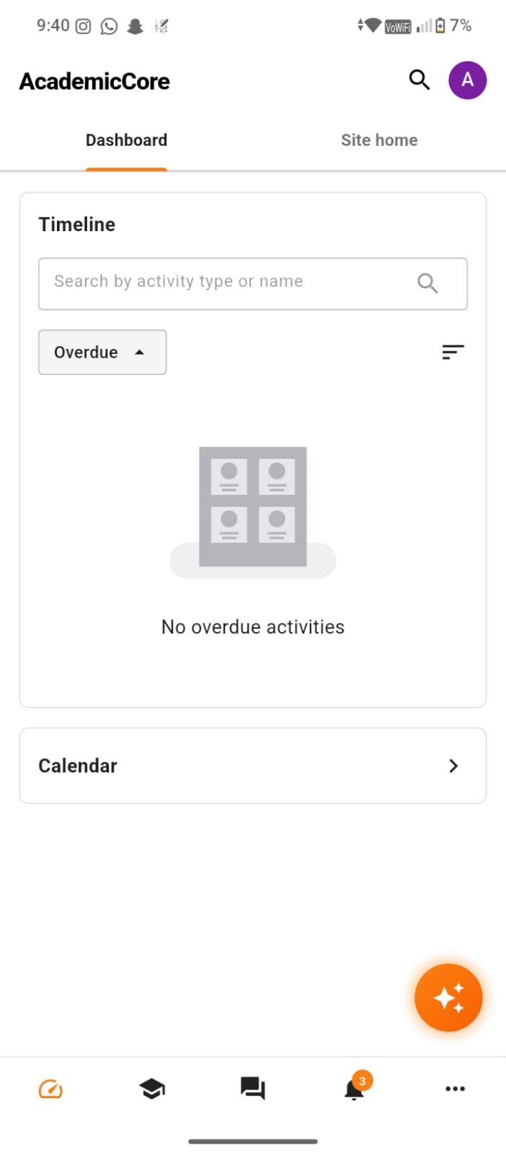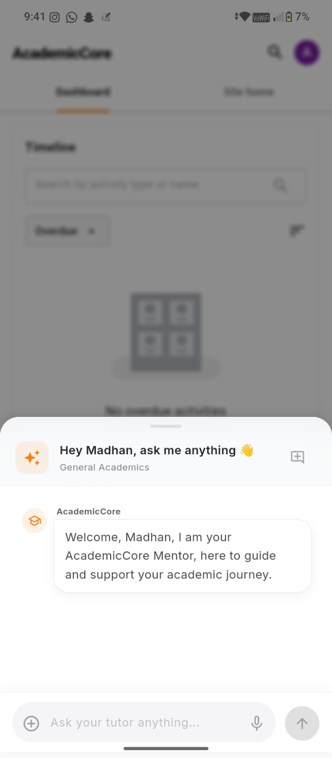
fig 4.2.1 fig 4.2.2
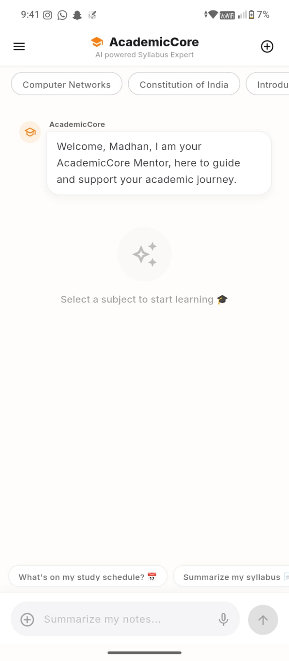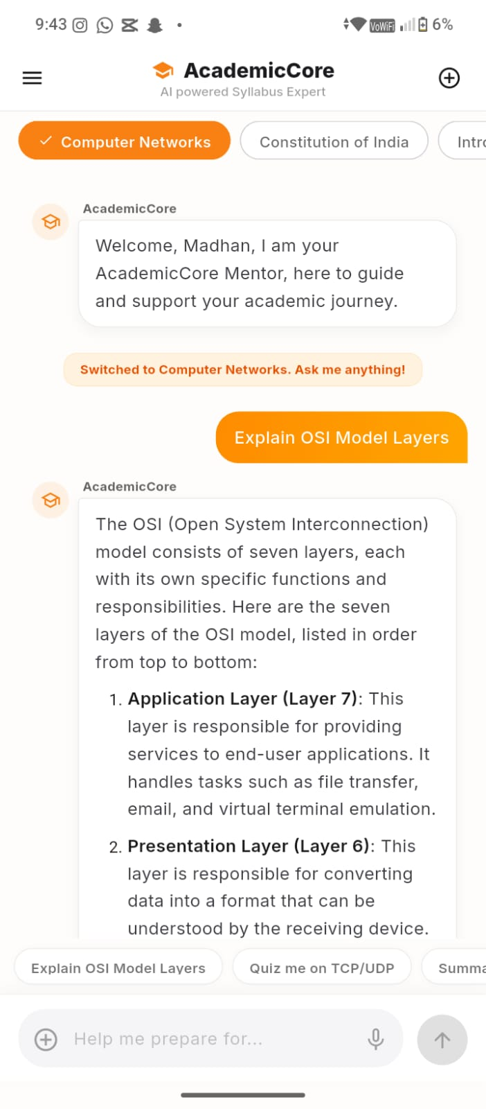
fig 4.2.3 fig 4.2.4

5. DISCUSSION
5.1 Challenges & Limitations
The development process encountered several technical and design challenges that required innovative solutions:

Render Server Inactivity
The Render cloud hosting platform automatically spins down inactive server instances after a period of inactivity. This caused delayed cold-start responses when students attempted to use the AI assistant after periods of low traffic. This was a significant reliability concern during initial testing.

Backend Response Delays
Initial API response times were higher than desired, particularly during peak usage periods. The multi-hop request flow from the frontend through the backend to the NVIDIA AI model introduced latency that negatively impacted the user experience.

Contextual Screen Data Management
Capturing and transmitting meaningful contextual screen data while maintaining user privacy and system performance required careful architectural decisions. Ensuring that contextual data was relevant and appropriately scoped to each interaction presented ongoing design challenges.

5.2 Lessons Learned
The following lessons were drawn from the challenges encountered during the project:
- Scalable Architecture Planning: Early consideration of scalability requirements is critical. The server inactivity issue highlighted the importance of designing for production-level reliability from the outset.
- Cloud Deployment Management: Managing cloud-hosted services requires familiarity with platform-specific limitations and proactive monitoring strategies. Node Cron Jobs proved to be an effective and lightweight solution for maintaining server availability.
- Context-Aware AI Design: Effective context-aware AI requires careful design of the data pipeline from screen capture to query construction. The quality of AI responses is directly proportional to the quality and relevance of contextual data provided.
- Iterative UI/UX Development: User interface design benefits greatly from iterative feedback-driven refinement. Multiple iterations of the bottom-sheet interface led to a significantly improved user experience compared to the initial design.

CONCLUSION
The AI Assistant for Academic Syllabus in LMS successfully demonstrates the potential of integrating context-aware artificial intelligence within modern Learning Management Systems. The project addressed a clear and present challenge faced by students in navigating academic platforms and accessing timely support.

Through the development of a Flutter-based LMS application with an integrated AI assistant powered by NVIDIA's AI models, the team delivered a functional system capable of providing real-time, context-sensitive academic support. The bottom-sheet interface design ensured a seamless user experience, while the Node.js backend provided a reliable and scalable processing layer.

The system demonstrated measurable improvements in LMS usability, student resource discovery efficiency, and query resolution quality. Technical challenges encountered during development, including server reliability and response latency, were addressed through targeted optimizations including cron-job-based server management and API flow improvements.

This project reinforces the value of AI-driven solutions in educational technology and establishes a strong foundation for further development of intelligent academic support systems. The integration of AI into LMS platforms represents a significant step toward making digital education more accessible, efficient, and student-centric.

FUTURE SCOPE
The current implementation of the AI Assistant for Academic Syllabus in LMS establishes a robust foundation for numerous future enhancements and extensions. The following areas represent significant opportunities for further development:

- Voice-Based AI Support: Integration of voice recognition capabilities to allow students to interact with the AI assistant through spoken queries, improving accessibility for diverse user groups.
- Personalized Learning Recommendations: Development of an adaptive learning engine that analyzes individual student performance and interaction history to deliver tailored course recommendations and study plans.
- Multi-Language Support: Extension of the AI assistant's capabilities to support multiple regional and international languages, enabling broader adoption across diverse student populations.
- AI-Generated Quizzes and Summaries: Automated generation of topic-specific quizzes and concise module summaries to support active learning and revision.
- Faculty Analytics Dashboard: A dedicated analytics interface for faculty members to gain insights into student engagement patterns, common areas of confusion, and AI interaction data.
- ERP Integration: Seamless integration with institutional ERP systems to provide students with AI-assisted access to examination schedules, attendance records, and academic calendars.
- Offline AI Capabilities: Development of lightweight on-device AI models to enable basic assistant functionality in low-connectivity environments.
- Advanced Adaptive Learning Systems: Implementation of sophisticated machine learning models to create fully adaptive learning pathways that evolve with each student's progress and learning style.

REFERENCES
[1] NVIDIA Corporation. (2024). NVIDIA AI Foundation Models Documentation.
[2] Supabase Inc. (2024). Supabase Documentation – Open Source Vector Database.
[3] Baker, R. S. (2014). Educational Data Mining and Learning Analytics.

